**University of engineering & technology Peshawar**



**Circuit & system-1**

**PSPICE Project**

**Fall 2020**

**Submitted by: Ashfaq Ahmad**

**Amir Suleman**

**Abdullah bin altaf**

**Section: B**

**Reg No: 19PWCSE (1795), (1805), (1816)**

**Semester: 2nd**

**Student signature: ____________________**

**Submitted to:**

**Eng: faizullah**

**Department Of Computer System Engineering**

Automatic Street Light

A simple project yet effective in terms of power save. Many times it happens during day time street lights are kept ON till someone notice thus leading to huge amount of energy loss.

**Software Used:**

* PSPICE – for circuit simulation.

**Step 1: Photo resistor or Light Dependent Resistor LDR**

A photo-resistor or light dependent resistor LDR is a component that is sensitive to light. When light falls upon it then the resistance changes.

Values of resistance of an LDR or photo-resistor change to several Mega ohms (MΩ) in darkness and then fall to a few hundred ohms in bright light. With such a wide variation in resistance, LDRs are easy to use in many application circuits. Here we will be using LDR to automatically control the demo Street Lights.

## Step 2: Transistors

Unlike resistors, which enforce a linear relationship between voltage and current, transistors are non-linear devices. They have four distinct modes of operation, which describe the current flowing through them. (When we talk about current flow through a transistor, we usually mean current flowing from collector to emitter of an NPN.)

The four transistor operation modes are: Saturation – The transistor acts like a short circuit or closed switch. Current freely flows from collector to emitter. Cut-off – The transistor acts like an open circuit or open switch. No current flows from collector to emitter. Active – The current from collector to emitter is proportional to the current flowing into the base. Reverse-Active – Like active mode, the current is proportional to the base current, but it flows in reverse. Current flows from emitter to collector (not, exactly, the purpose transistors were designed for).

Here in this application NPN transistor 2n2222 will be operated in Saturation (closed switch) and Cut-off (open switch) modes. There are variants available of 2n2222 as plastic (TO-92) and metal(TO-18) form. I have used metal one since more current handling capacity from collector to emitter (max. 800 mA).

## Step 3: Circuit Diagram

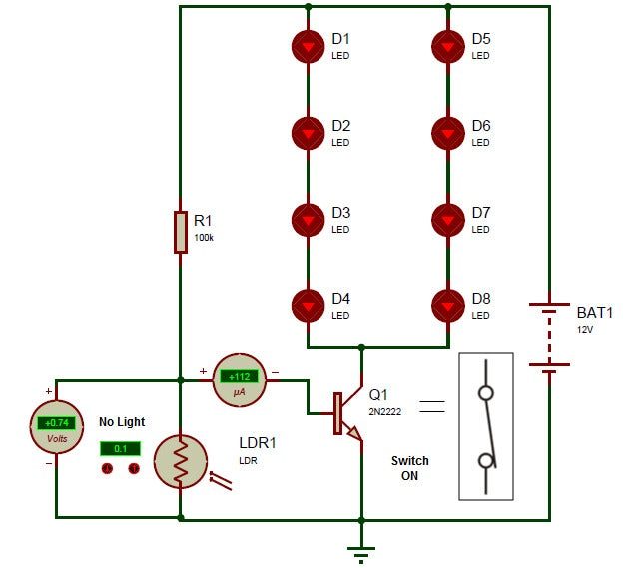

## 

## Step 4: During Presence of Light

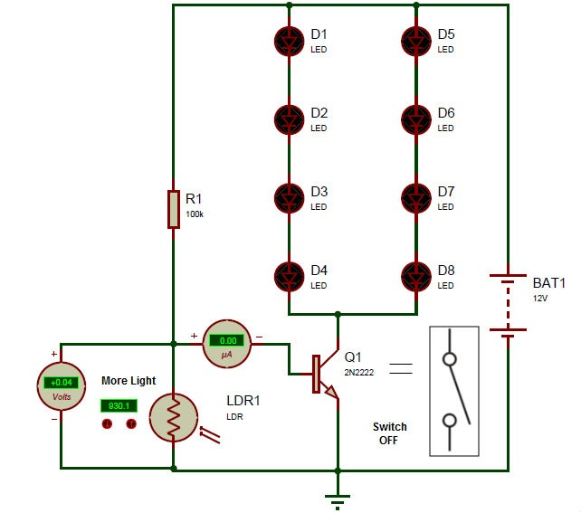

When there is Light during day time then LDR resistance decreases. This makes voltage at base less than 0.6V and so, transistor moves in Cut-off mode – no current flows from Collector to Emitter acting as open switch.

## Step 5: During Absence of Light

## https://cdn.instructables.com/ORIG/FM3/LNVW/JIEU06GH/FM3LNVWJIEU06GH.jpg?auto=webp&frame=1&fit=bounds&md=70cc4226f0942acd5e19c1b92edfed26

When Light intensity starts to decrease than LDR resistance increases. This makes voltage at base greater than 0.6V and so, transistor moves in Saturation mode – current flows from Collector to Emitter acting as closed switch.